THE PRESIDENTIAL POPULARITY CONTEST

*A look into the history of presidential approval ratings and what they mean.*

By Kayla Gallagher

The concept of presidential popularity is a simple but powerful thing in American politics. This popularity is examined using a presidential approval rating.

In the early 1930s, George H. Gallup, founder of the American Institute of Public Opinion released the first ever public opinion poll to obtain and summarize the American public’s thoughts of then-President Franklin D. Roosevelt’s New Deal. The poll revealed 60% of Americans thought the New Deal was going to be too expensive.

Eventually, more presidential polling was conducted to give the public a chance to further voice their opinions on how they thought each president was performing and his policies. The basic question of presidential approval ratings is: “Do you approve or disapprove of the way [insert President’s name here] is handling their job as president?” [according to TIME](https://time.com/5511118/presidential-approval-ratings-history/).

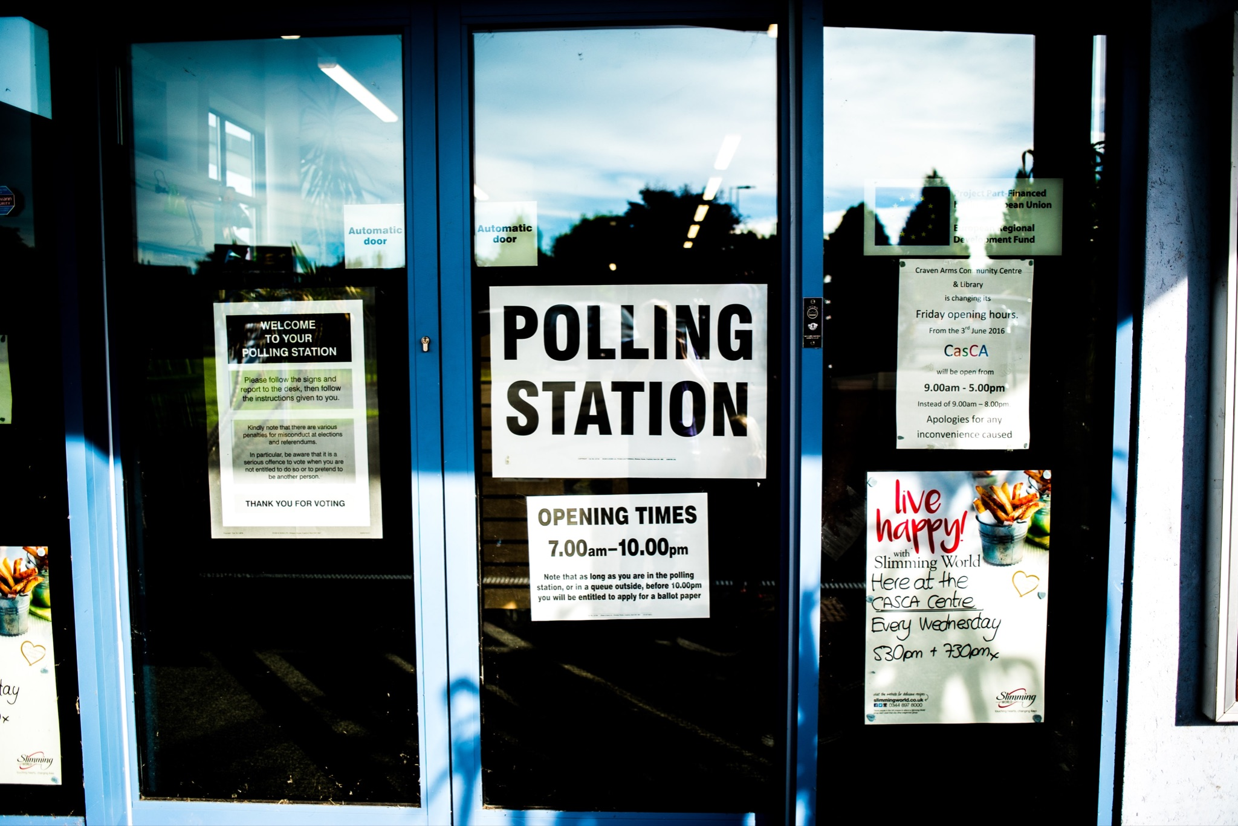

*Organizations like Gallup, Rasmussen and FiveThirtyEight all conduct public opinion polls in order to calculate the approval ratings of each American president. (Unsplash / Elliott Stallion).*

William Lyon Mackenzie King, a Canadian journalist and politician, once famously said, “Where there is little or no public opinion, there is likely to be bad government, which sooner or later becomes autocratic government.”

A number of factors are taken into account when calculating a president’s approval rating, such as national unemployment rates and the state of the economy during their presidency. However, much remains to be seen about the direct impact of these numbers. Analysts have looked into how these numbers can influence an in-office president’s political party and how approval ratings have developed over the years.

Gallup Analytics, a global analytics firm formerly known as the American Institute of Public Opinion, has an interactive Presidential Job Approval Center where they have tracked public opinion metrics for the last 75 years.

In July of 2021, Gallup did a Q&A between Frank Newport, a Gallup senior scientist, and Lydia Saad, a senior editor for The Gallup Poll with Business Insider, who co-authored an article for Public Opinion Quarterly called, “[The Polls – Review: Presidential Job Approval](https://academic.oup.com/poq/article-abstract/85/1/223/6314573?redirectedFrom=fulltext),” where they share facts into the public opinion research Gallup has done over the last seven decades.

“I think Dr. Gallup felt there was a need for a measure of how well the president was doing between elections,” [Newport said in the Q&A](https://news.gallup.com/opinion/polling-matters/352739/measuring-presidential-job-approval-years.aspx). “In much of his work, he argued forcefully for the need to understand and analyze public opinion in ways that went beyond, but didn't supersede, voting.”

According to evidence outlined in Newport and Saad’s article, presidential approval may be more of a measure of party loyalty than an actual presidential performance assessment. The article points out that the “increasingly rigid partisan politicization” of presidential approval ratings suggests that there is less variation in the future.

“…For me, the most important takeaway is that the question was not as inevitable as it may seem,” Saad said in the Q&A. “As pollsters who have asked it thousands of times over our careers, it's easy to take the presidential approval item for granted because it is so ubiquitous.”

FiveThirtyEight election analyst Geoffrey Skelley told ABC News in Jan. that the higher a president’s approval ratings is, the better their political party tends to do in terms of earning Congressional seats.

"The higher a president's approval is, the better his or her party tends to do," Skelley said.

This analyzed data set looks at the last ten presidents of the United States and observes the average approval ratings of each and whether or not the president’s political party had any influence on these numbers and if they truly matter to the people.

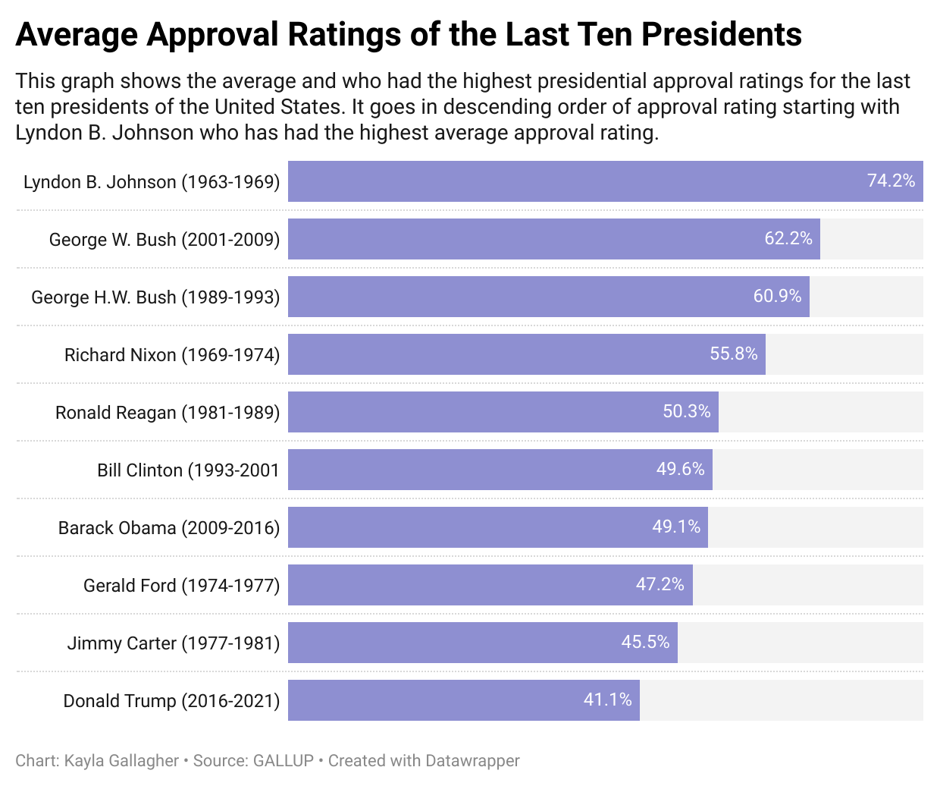

Out of the last ten presidents who have served the nation, Lyndon B. Johnson has the highest average approval rating of 74.2%.Johnson’s presidency began after the assassination of President John F. Kennedy, leaving the vice president to serve one partial term before he was re-elected for a second term.

There could have been a number of things that contributed to Johnson having such a high average including the passage of the Voting Rights Act of 1965 and a general sense of unity for the country after the beloved J.F.K. was assassinated.

Due to the situation in which Johnson became president, data shows that his political situation led to him having the highest approval rating. During his almost two-term presidency he had the lowest average unemployment rate at 4.2% and the highest GDP growth at 5.3%.

The president with the lowest approval rating from the last ten presidents was the 45th president of the United States, Donald Trump with an average rating of 41.1%. Despite his controversial presidency, Trump had the second lowest unemployment rate at 5.0% after Johnson. However, Trump also had the lowest Gross Domestic Product (GDP) growth with an average of 1% during his presidency.

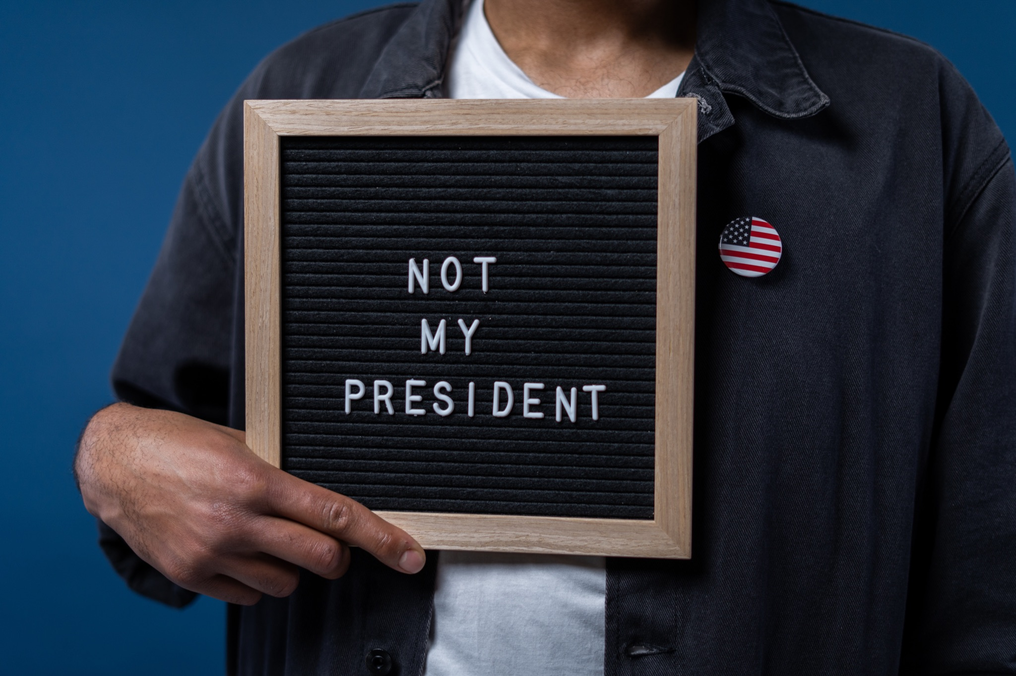

*“Not my president,” was a common phrase used by people who did not support former President Donald J. Trump. According to Gallup Analytics, Trump has had the lowest average approval rating of any president since Harry S. Truman. (Pexels / cottonbro).*

In the Gallup Q&A with Saad and Newport, Saad said their research showed Trump having the lowest first-term average of any president in Gallup’s history since Harry S. Truman.

FormerPresident George W. Bush has seen high approval ratings from the nation at 60.9%. During his presidency, however, Bush hit a record-high approval rating of 80% shortly after the terrorist attacks on the Twin Towers in New York on Sept. 11, 2001.

Four out of the last ten United States presidents have been Democrats, and the other six were Republicans.Out of these presidents, two have been impeached: Bill Clinton and Donald Trump. Clinton’s impeachment followed the Monica Lewinsky scandal and Trump was impeached twice during his four-year term. Richard Nixon faced potential impeachment after the Watergate scandal but resigned early into his second term before it could happen.

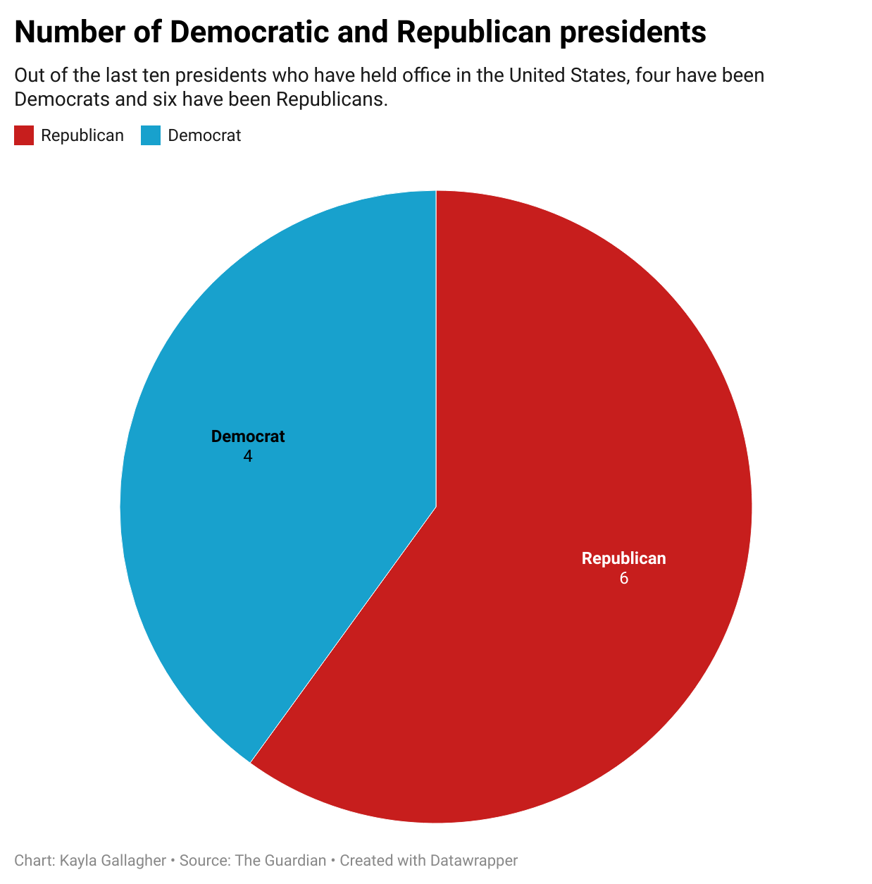

Overall, this data shows how the ups and downs of each presidency such as inflation and impeachment can affect the public’s opinion of the job the president is doing in office.

ABC News Political Director Rick Klein describes the presidential approval rating as a “snapshot.” It is an opportunity for the people to say whether or not they approve or disapprove of the job the president has been doing, he says.

“When it comes to the president's approval rating, everything matters. But you can also say that nothing is determinative,” [Klein told ABC News in Jan](https://abcnews.go.com/Politics/presidential-approval-number/story?id=82270449). “What does happen is an accumulation of storylines and things that people read and hear and are told, those add up to the general perceptions of a president.”

The results of these numbers can cause important consequences for presidents in office. Some presidents have lost Congressional seats for their parties due to low approval ratings.

Although these numbers and percentages may help contribute, some presidential popularity experts say the results of these numbers are really just about general perception and the mood of the country.

For example, according to FiveThirtyEight, as of March 4, current President Joe [Biden’s presidential approval rating is 52%](https://projects.fivethirtyeight.com/biden-approval-rating/). This number comes from polls answered by likely or registered voters and adults. This comes after Biden’s State of the Union address where he touched on multiple relevant issues including Russia’s invasion of Ukraine, the state of the coronavirus pandemic and inflation.

According to [NPR](https://www.npr.org/2022/03/04/1084463809/biden-approval-poll-ukraine-economy), the State of the Union seemed to help Biden’s approval ratings, showing an example of how the general mood of the country influences public opinion.

“It doesn't mean that you agree with everything or disagree with everything … it's about the general perceptions,” [Klein told ABC News](https://abcnews.go.com/Politics/presidential-approval-number/story?id=82270449). “It comes back to that national mood.”

##

Original Data Set: <https://docs.google.com/spreadsheets/d/17ipWQ509ORVcZKgMW4nM249MkW8ibcDbK2rQdaVW0Fg/edit#gid=0>

Data Diary:

In order to obtain this data on presidential approval ratings I:

1. Gathered the names of the last 10 presidents who have served the United States through a simple Google search.
   1. In this research I also accumulated information about their political parties, whether or not there was a war during their presidency and how many terms they served.
2. I then used information from Gallup Analytics to determine their average presidential approval rating during their presidency.
   1. I didn’t have to calculate these numbers because Gallup had already done so [here](https://news.gallup.com/poll/116677/presidential-approval-ratings-gallup-historical-statistics-trends.aspx).
3. Next, I calculated the average unemployment rate of each president during the terms they served.
   1. I only had to compile this data because History in Pieces had already calculated the averages [here](https://historyinpieces.com/research/us-unemployment-rates-president).
4. I did have to calculate the average Gross Domestic Product growth of the last 10 presidents.
   1. To do this I used data from [The Balance](https://www.thebalance.com/gdp-growth-by-president-highs-lows-averages-4801102) that showed what the average GDP was for each president each year of their presidency. I added those numbers up and divided it by the term-length in year by each president in order to calculate the averages.
5. Since this data is more of a collection of data in order to create one larger data set, I didn’t have to do muhc cleaning, but I did need to come up with consistent names for each column so that they would be easier to navigate.
   1. For example, in categorizing the number of terms each president served, I had to come up with consistent phrasing, so a search of the data could be properly conducted.
      1. One partial and one full
      2. One full term and resigned during second term
      3. One full term
      4. Two full terms
6. For the last column that indicates whether or not there was a war during the presidency, I just researched whether or not there was one and categorized it by a simple “yes” or “no”
   1. Note: this does not indicate whether the war was started or ended during the president’s time in office. Nor does it indicate what war it was.
7. To create my second data visualization of how many presidents were Democrats and how many were Republicans over the last 10, I created a new data set that counted the total number of Democratic and Republican republicans.

**\*\*Note: I attempted to interview my own sources throughout the semester, but unfortunately I did not have much luck. Here is a list of people/organizations I contacted, but either never heard back from or they were unavailable for an interview:**

Gallup Analytics

Becky Strauss, D.C. Policy Center

Rasmussen

Jeremy Darrington, Princeton University

Geoffrey Skelley, election analyst for FiveThirtyEight

Kathleen Weldon, Roper Center for Public Opinion Research

Cliff Zukin, Professor of Public Policy and Political Science at Rutgers University

Pew Research Center

Steven Smith, Professor of Social Sciences and Political Science at Washington University in St. Louis